Playwaze – entering scores (this guide assumes that you have registered and have an account in Playwaze).

Login to Playwaze
https://playwaze.com/login
Select the HADTL community – you should then see the 2022 men’s and Ladies leagues
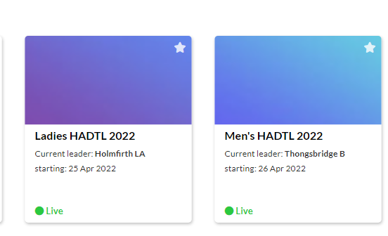

Select the relevant league, the default will take you to division 1.
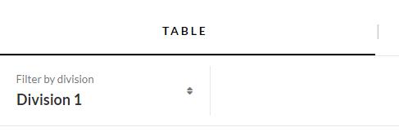

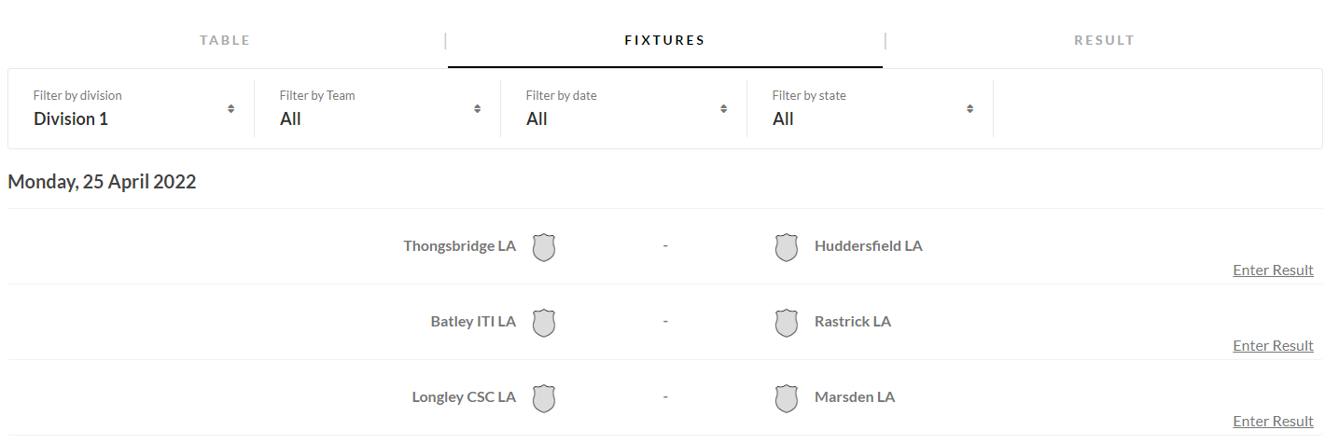

Select the division required, scroll down to the fixture played.
To the right of the fixture is an ENTER RESULT button. Select.
THE NEXT SCREEN WILL REQUIRE YOU TO ENTER THE PAIRINGS FOR BOTH TEAMS. PLEASE REMEMBER THE WINNING TEAM IS RESPONSIBLE FOR THE UPDATE OF THE FIXTURE AND UPLOADING OF CARD.
Select the drop down box to select the players, then select update Players button.

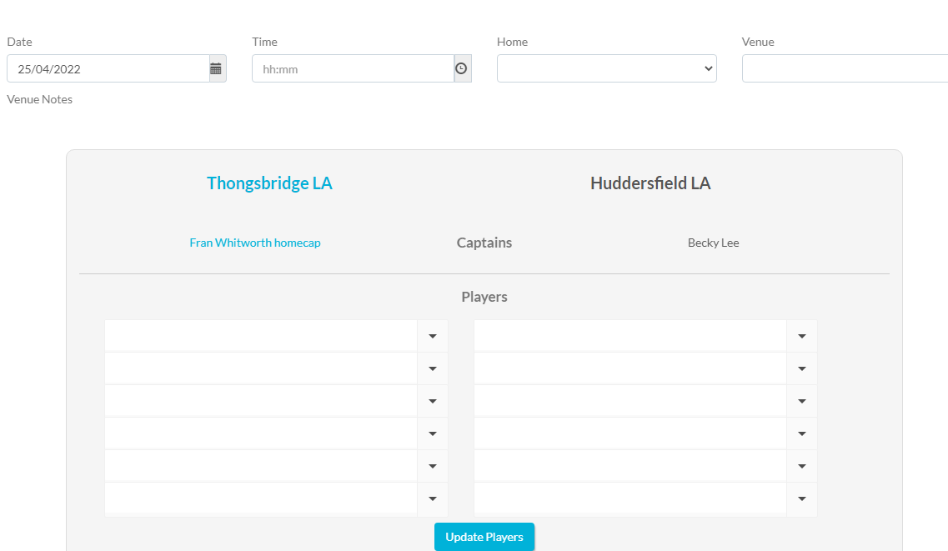
Once the players have been added, you can then enter the pairings and results for each set.

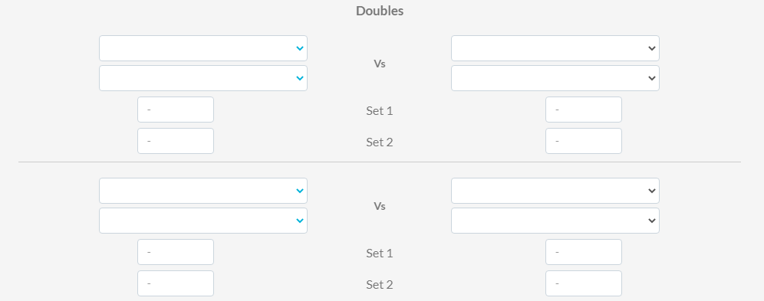

After all results have been entered, select calculate result button
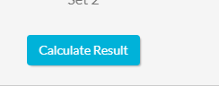 Then select SAVE.

The result will not appear in the table, until the result has been approved by the match secretary.
It is important that the scorecard is either copied and uploaded to the captains whatsapp group, posted to the match secretary or uploaded into Playwaze.
Please note it is not acceptable to wait until the end of the season to post the match cards. They are needed in case of any disputes and random checks..

For electronic upload of scorecards, first scan/ save image of the completed scorecard select the upload match card button, select file and save.
